Special Schools and Museums Toolkit

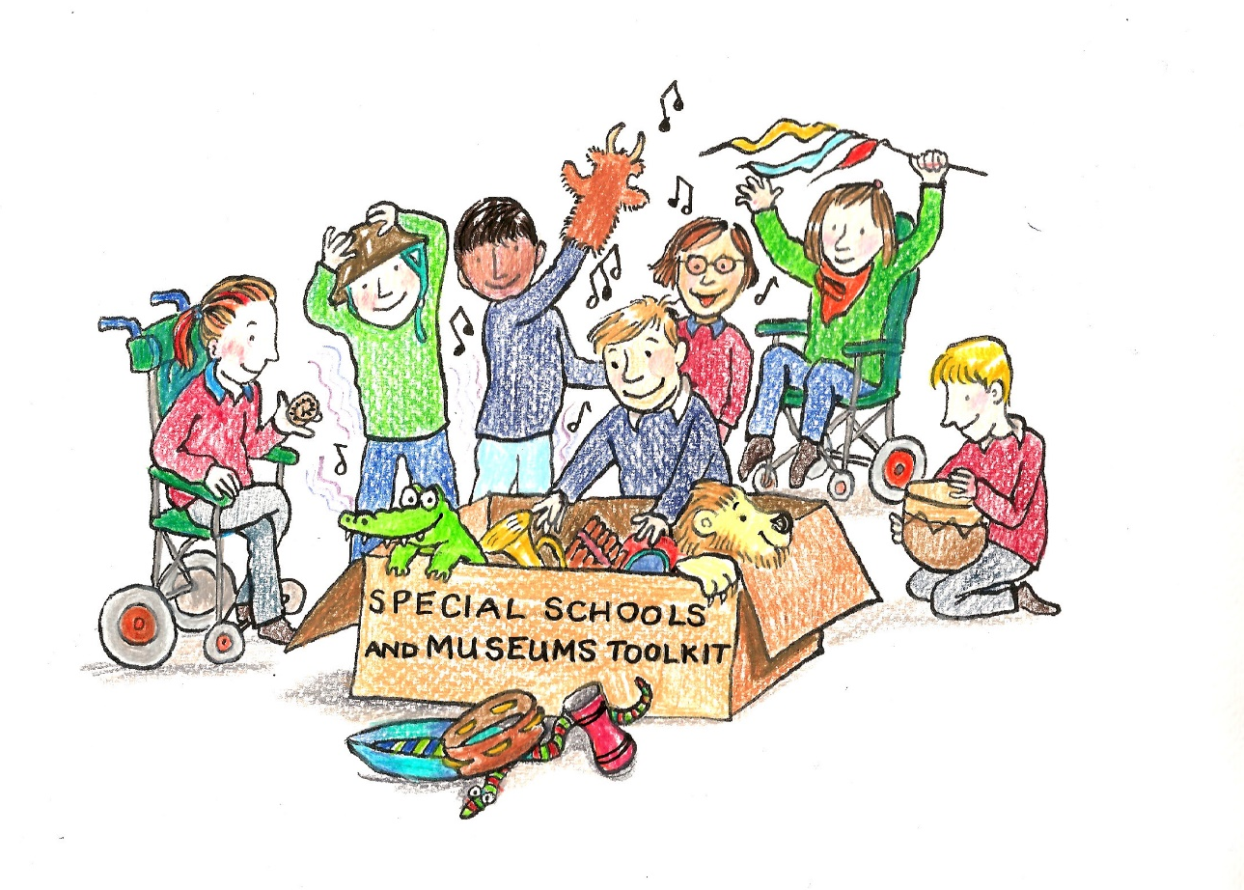

A practical guide to accessible and inclusive museum experiences for special schools and SEND families

Contents

Foreword

Introduction

The important but dry stuff!

Background of the SEND Landscape UK
Social and medical models of disability
SEND/Special Schools and Special education in UK

How to Explore the Toolkit

Getting started
What special schools need (plus what kind of activities)

How to get schools involved

Things to think about at your Museum

Walk through tour with teachers

Checklist

Accessible website

Access statement

Booking procedure

Top tips for creating a successful visit

In advance

On the day

Afterwards

Case Studies
Case study 1 Teacher led visits at Dover Museum

Case study 2 Bronze Age Boat Sensory Story at Dover Museum

Case Study 3 Splendiferous Carboniferous Sensory Story at the Kent Mining Museum

Case Study 4 Visual Gallery Guide and WW1 loan box at the Royal Engineers Museum

Appendices

Appendix 1 Legal Framework of Disability

Appendix 2 Useful Links

Appendix 3 Disability Awareness Training

Appendix 4 Access and resources checklist

Appendix 5 Good Practice Examples

Appendix 6 Glossary of terms

Appendix 1
“There is no greater disability in society, than the inability to see a person as more”. Robert M. Hensel

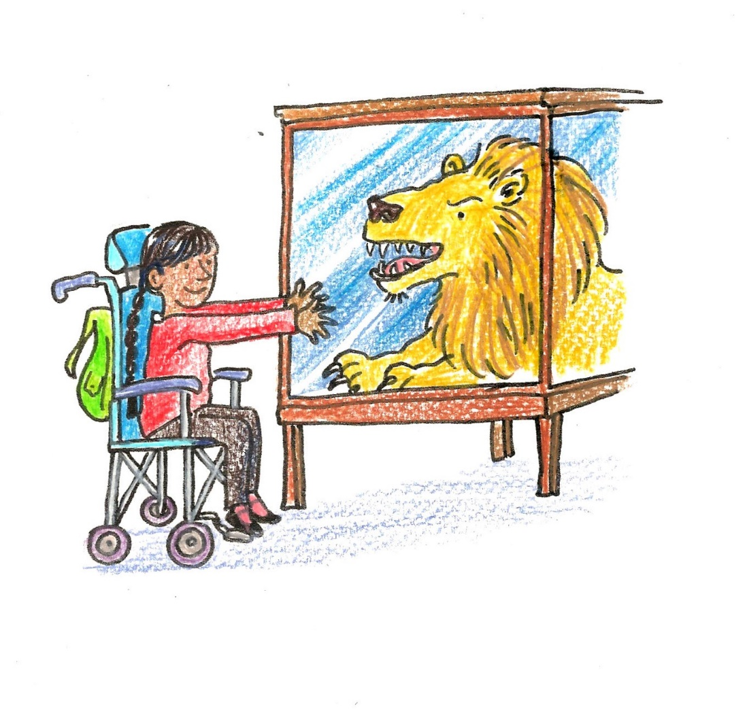
Appendix 1 Glossary of Terms
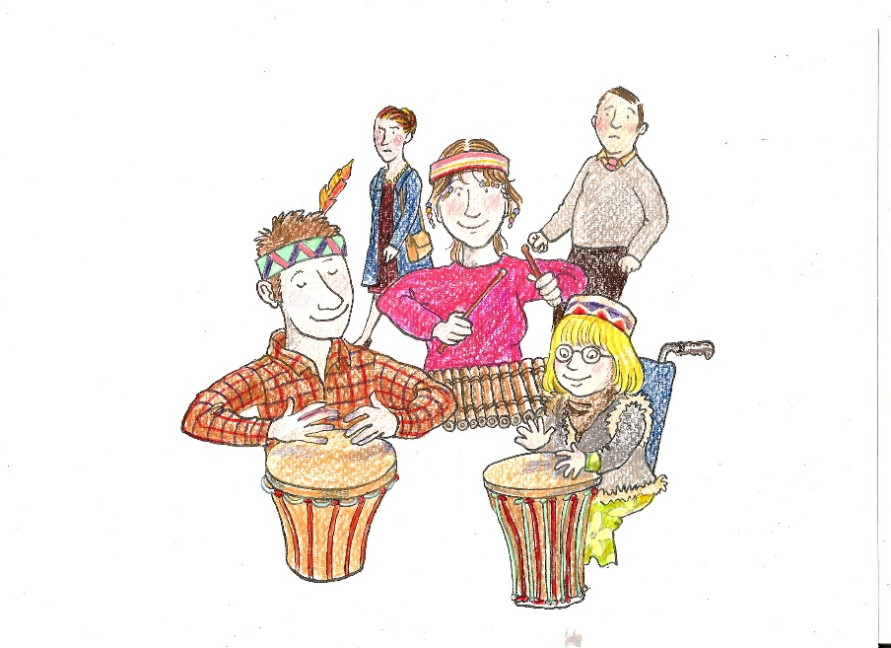
Should they be having that much fun in a museum?!
Foreword
Welcome to the Special Schools and Museums Toolkit - the product of a South East Museum Development Program (SEMDP) project, linking museums with special schools in Kent.
I’ve worked in museums for twenty years often thinking accessibility was about ramps, text size and feely bags! However it wasn’t until I became a parent to a child with severe physical and learning disabilities that I realised the depth of difference between ‘accessibility’ and ‘inclusion’. Keen to share my love of museums with my daughter, I’ve often struggled to shape our experience into a meaningful one. Sometimes museum staff have been able to adapt and be truly inclusive. We’ve also used exciting handling collections to create our own world - wildly beating drums and xylophones whilst wearing tribal headgear, much to the shock of other visitors. However, these are rare occasions and more often than not, we’ve been limited by the constraints of an activity designed for a non-SEND audience, or by staff who lack confidence to interact with us.
As Museum Development Officer, I was given to opportunity to address this need
directly. The museums and special schools who took part in the project have worked with a level of energy and passion which was inspiring. This toolkit reveals how empowering this can be, and what can be achieved with creativity, partnership working and surprisingly little money.
It’s important to acknowledge that one of the main barriers to inclusion is fear. Fear of the unknown, of the other, of saying or doing the ‘wrong’ thing. This toolkit is designed as a user-friendly resource to help museum staff overcome this fear and become more SEND inclusive. I’ve been lucky to work with heritage learning consultant Martin Crowther on this project; with inspirational museum educators and teachers; and some amazing children. Together, we hope this toolkit gives you an insight into this magical world of difference and sets you on an exciting and rewarding journey to embracing SEND audiences in your museum!

Sam Bowen - Museum Development Officer, Kent and Medway
I’ve got my teachers on board, I can’t wait to develop these resources!
I can get a whole term’s work out of this!

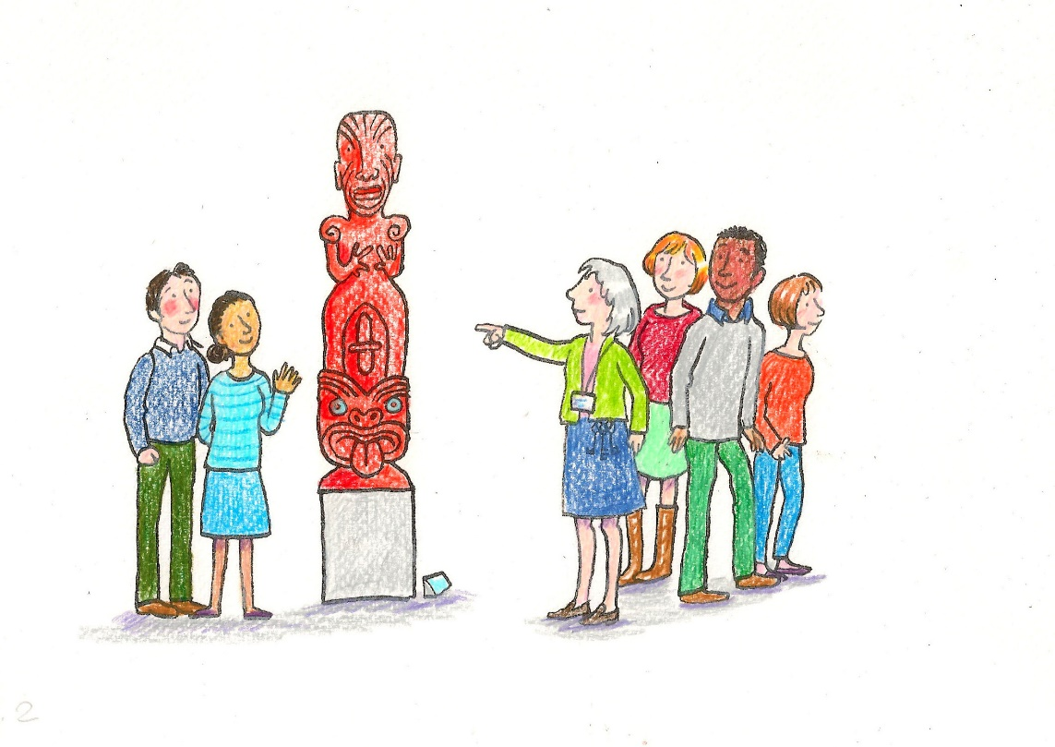
Such wonderful opportunities for hands-on learning!
Introduction
This toolkit is a beginner’s guide, offering practical advice and real life case studies from Dover Museum, the Kent Mining Museum and the Royal Engineers Museum, highlighting simple low cost improvements you can put in place with the support of local teachers, to make visits by special schools and SEND families welcoming, accessible and inclusive. We’ve also signposted best practice elsewhere in the UK.
We hope this toolkit will also be useful for teachers looking to build sustainable relationships with their local museums, and to give their students access to high quality learning experiences, inspired by museum artefacts and heritage sites.

We’re assuming no prior knowledge of SEND audiences or their needs as visitors. Specialist terms are often unavoidable, but we’ll keep them to a minimum, and have included a jargon-busting Glossary of Terms.

The toolkit is light-hearted and conversational. We know some of the issues can be daunting, but we also feel that overcoming this fear of the unknown can bring fun and rewarding experiences for museum staff and visitors.
A big thank you to Charlotte Firmin, whose wonderful illustrations will hopefully bring a smile to your face, as they have to all the children, teachers and museum staff who’ve seen them so far!

Background of the SEND Landscape UK
This toolkit is based on terms, legal reference and best practice within the UK (as of March 2018). It’s worth quickly noting that guidance elsewhere may be different.

SEN or SEND? What’s in a name? Good question!

- SEN stands for Special Educational Needs.

- SEND stands for Special Educational Needs and Disabled (or Disability)

For our purposes these mean the same in terms of audience needs and inclusivity. SEN however is a legally recognised term used in legislation like the Equality Act 2010 and Children and Families Act 2014. We also want to address physical barriers to accessibility in our toolkit so we will use the term SEND throughout. If you’d like more information about the SEND landscape in the UK look at our summary and weblinks in the appendices.

Disability and identity

First and foremost it’s important to remember that people are people and thankfully we are not all alike, can you imagine how boring that would be?!

The trouble is, disability or rather impairment, is sometimes used as a qualifying description which overlooks so much else about the person. The term disability can itself present a barrier almost immediately. It’s a complex subject with interesting debate but the two main thoughts are the Social and Medical models that ascribe disability either to the barriers posed by society and equal access to it, or the physiological and neurological effects of a condition which are seen to be ‘fixed’ through medical or therapeutic intervention. See appendix 2 for links to more articles about this.

For now just keep in mind that although we may need to ask questions about a person’s disability when planning to make their museum visit the best it can be, remember that the engagement itself is with the person, despite their impairment. It’s also important to note that there are many forms of ‘invisible’ disability or impairment that you will not know about unless you ask if the person needs assistance.

Definition of disability under the Equality Act 2010
You’re disabled under the Equality Act 2010 if you have a physical or mental impairment that has a ‘substantial’ and ‘long-term’ negative effect on your ability to do normal daily activities.

Ask yourself given this definition if you know someone who is disabled or has an impairment and the chances are you do. The current UK figures are on the SCOPE website.
There are 13.9 million disabled people in the UK. 8 %of children are disabled.
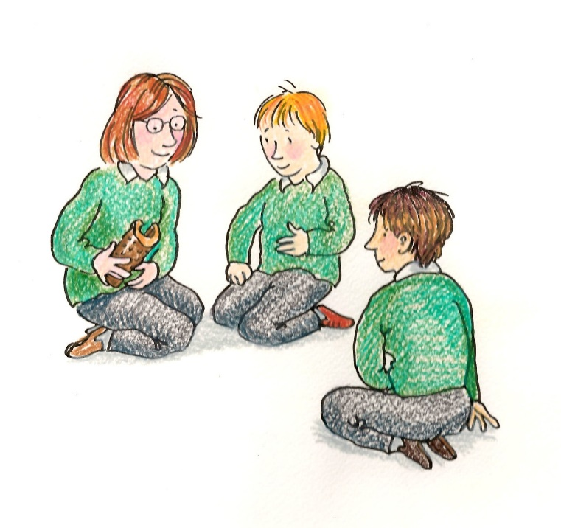

How are SEND schools different to ‘normal’ or mainstream schools?
Look … we just said the word ‘normal’ and the sky didn’t fall in! OK, so the preferred term for a non-special needs school setting is ‘mainstream’, but even within these schools there are often SEND children studying alongside their non SEND peers, perhaps with additional support, or within a specialist unit.

Some SEND children also attend mainstream schools as part of a satellite learning system whereby their class is ‘on roll’ at the special needs school but attend a mainstream setting as part of their inclusion program. The reason for pointing this out here is any school who books a visit to your museum may have SEND children within the visiting class. If you don’t ask at the booking stage, you may not know until the visit and therefore miss the opportunity to prepare for their needs.

Special needs schools, or units within mainstream will generally have higher staff to student ratio than mainstream schools and often cater for a large range of needs. They may also visit in smaller groups but have very specific needs (look at our case studies for inspiring ideas!).

Nationally however this is not a small group folks! According to the Department of Education, in January 2017 there were 11,244,255 children in the UK with Special Educational Needs (SEN) which is14.4% of all school age children. Of these 25.2% had Moderate Learning Difficulty as a primary type of need. 26.9% of pupils with a statement or EHC plan had Autistic Spectrum Disorder as a primary type of need.
For figures relating to the number of children in your area with SEND who have an Education and Healthcare Plan (EHCP) you can find this information on your local authority’s website. It’s worth noting however that not all children who are SEND are awarded an ECHP.
Outside of school, working with your local SEND family support groups is a good way of developing understanding about disability inclusion and building relationships and accessible visits for SEND families.
Details of such groups in your area can be found by contacting your Local Authority, Social Services Disabled Children’s Team or your local Citizens Advice Bureau.

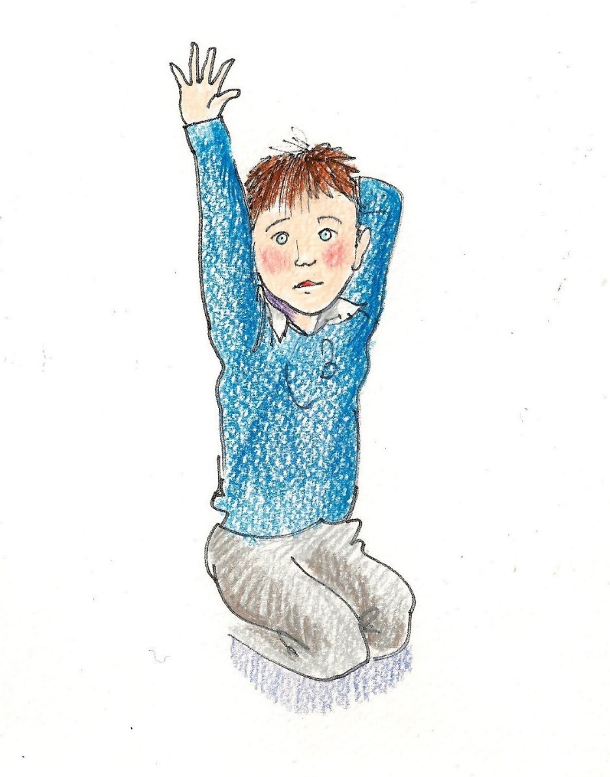
How to explore the Toolkit
The toolkit is divided into clear sections, so you can quickly find what you need.
Getting Started looks at what special schools need as part of a museum visit, and how to get schools involved. A big thank you to our partner teachers for providing lots of useful information and ideas here.
In Things to think about at your Museum we encourage you to think about how your museum matches up to these needs and evaluate how you can meet them.
The Practical Tips and Dos and Don’ts sections offer simple advice from experienced museum educators and teachers and are incredibly useful.
We also take a brief look at SEND Families (as it’s highly likely that a positive school visit will lead to a child wanting to return with their family) and look at how you can develop a high quality offer for them too.
This is followed by our four Case Studies, which show how small and medium sized museums with little or no budget can create inspirational visits… and will hopefully encourage you to do likewise!
Finally, a Useful Links section signposts examples of best practice elsewhere. We’d like to thank staff from these museums for their advice and support, not least members of the London SEND Network who’ve been so welcoming and supportive. Please note this information is current as of March 2018 and may change.
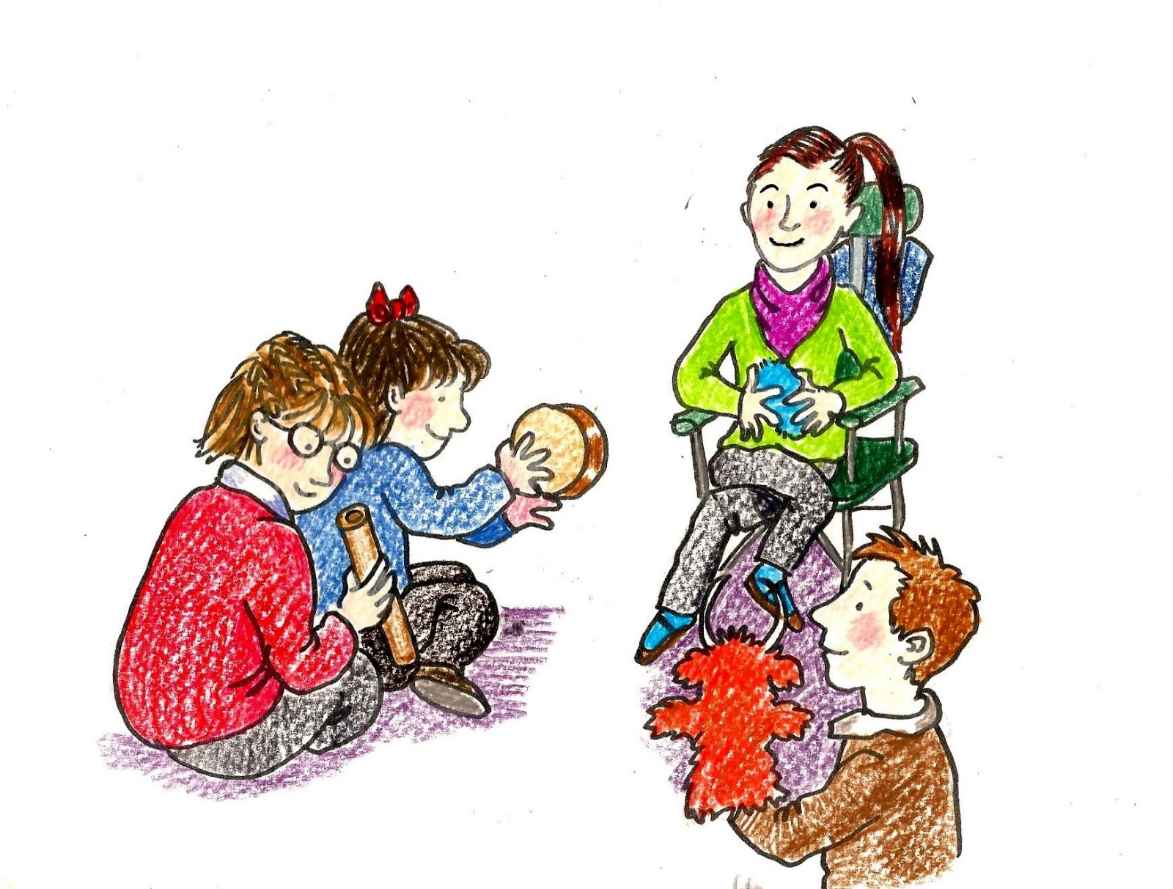Getting started - what special schools need
‘Offer safe experiences that challenge boundaries!’

Work with teachers in advance to identify key access requirements and activities that need to be put in place to make a special school visit a success.
A pre-visit face to face meeting and walk round the museum is important, but if that’s not possible make sure you talk on the phone.
Below are key things teachers said special schools needed from a museum visit.
- To know which areas are accessible for children in wheelchairs and with other access needs.

- A Safe Space or quiet room where a child can chill out.

- Parking for Minibus ‘High Tops’ ideally free of charge and next to the museum, or for safe drop off outside, with nearby car parks highlighted.

- Free pre-visits for teachers to chat to museum staff about the visit, discuss activities and specific needs, and to do a walk through and risk assessment.

- The museum booking system and staff taking bookings needs to ask appropriate questions to identify and accommodate the needs of SEND children.
- Adult-pupil ratio is higher, so have a reduced carer rate or free ticket.

- Clear access information is needed on the website to help plan a visit.

- The museum website should highlight sensory challenges children might experience around the museum such as changing light levels, flashing lights, and loud or unusual noises..

- Multi-sensory resources, object investigation activities, and large print text.

- Accessible toilet facilities and a space to change larger children, ideally a change bed.

- Access to a quiet room for tube feeding and administering medication

- Separate lunch space, ideally not shared with another school

- Audio and multisensory displays and interactives

- Sound cubes, smelly cubes, or handling collections

- Teachers NEED to be able to use their mobile phones for safety reasons. A no phone policy within the museum will put SEND teachers off visiting.

- SEND schools/groups need flexibility. The option to change time/date/type of visit or possibly cancel at short notice.

- Schools need to be updated of any changes at the museum, such as a new layout, or new exhibitions. Suggest school joins museum’s mailing list.

- Familiarisation information about who works at the museum and what they do would be great!. For example My name is… I work as… My favourite colour is… This could be sent to the school in advance with a photo of the different people the children will meet.

- Simple and clear map/floorplan of the museum identifying where toilets, lunch room, activity spaces/galleries and shop are.

- Some schools would prefer a reduced-choice option in the museum shop, with children offered a small selection of pocket money priced gifts, either as a pre-paid option or at the point of sale.

- Consider stocking sensory toys in the shop.

- For children with autism, DON’T talk too much!

- Use short stories to hook an audience and break story down to bite-sized pieces

- Train staff and volunteers about appropriate language and non-verbal behaviour (body language)

- Train staff on simple Makaton signs such as Hello, How are you? Wait, Stop! Yes/No, Good, Goodbye.

- Offer safe experiences that challenge boundaries. Help children to experience something new and different

- Recognise the whole of the museum experience is valid and valuable. Keep activities loose and open-ended, not target or results driven.

- Ask museum front of house staff to tell other visitors on the day about the SEND school visit so they know what to expect.

- Inform school staff and children about what to expect. For example, if a member of museum staff/volunteer will be dressed in character

- Involve the children. Welcome them! Chat to them, show them around.

What museums need – and need to tell teachers!
- Museums need schools need to be honest about their needs and the level of risk associated with their group so they can plan accordingly

- It is essential that schools do their own pre visit risk assessment in addition to risk assessment advice provided by the museum

- It is useful to know of any alternative activities the museum could have on standby, if the first choice activity doesn’t work.

- Museums need as much advance notice of a booking or changes to a booking as possible.

How can I get a partner school on board?
How do I make my museum accessible?
What about children with autism?
What resources do teachers want?

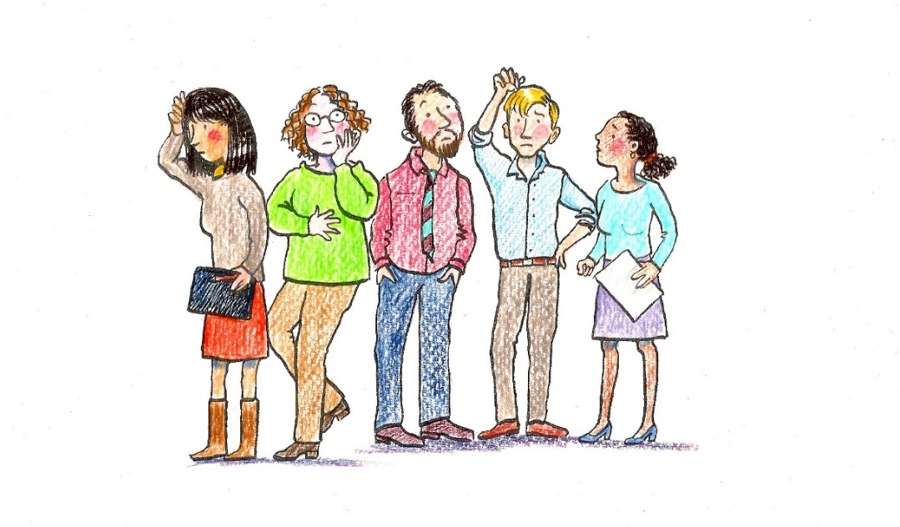
What can we do on a small budget?
Things to think about at your Museum

So far we have looked at what Special Needs school groups need to make a trip to a museum successful. There are quite a few things here that you may already do well, but there are always areas to improve on! It’s worth doing an ideas mapping session with all staff on this issue to assess how you can become more SEND friendly.
A SWOT analysis to highlight Strengths, Weaknesses, Opportunities and Threats is also a quick and easy tool to identify areas of improvement.
Do these before you approach a special school to gain their advice and you will have already started on the right track.
Some things that you might want to consider are…

An Accessible website
Museums should all include an access statement on the access page of their website outlining the access arrangements for different audiences. This should also promote and signpost the activities and resources that are available at the museum for special schools and families with SEND children. See the great example from the Discovery Centre in Stratford, London www.discover.org.uk/access-statement/
Being able to plan a visit is vitally important for SEND schools and that’s also true for other groups and families.

Changing Places toilet
You may have heard in the news about national campaigns for organisations to install Changing Places toilets. These are larger than standard disabled access facilities and incorporate a change bed, hoist and usually a shower. This is because anyone over the age of about 3 years is unlikely to fit on a baby change bed and the only other alternative is to lie on the toilet floor, not nice. Check out www.changingplaces.org for more information and a map to find where your nearest one is. Your local council should also be able to tell you this. There is also a ‘Space to Change’ campaign by www.fireflycommunity.com that advises smaller organisations on useful adaptations to meet this need when installing a Changing Place toilet is not possible.
If no local offer is available then working with the SEND group/school to create an alternative such as a private space to change, a floor mat or folding massage bed/change bed will make a big difference to their visit experience. First Aid rooms are often used for this, even in large Visitor attractions such as Disneyland Paris!
Similarly, being flexible about the museum space and how it can be used is important. I recently met someone who works for a national cinema chain, when the need arises for a child or adult to have a ‘quiet space’ the staff vacate their office to accommodate this. Being sensible about risk vs need means you can be a more approachable and SEND friendly environment.
Design open ended activities with ‘no end result’ built in

When planning activities for visitors, don’t forget the ‘no end result’ rule …
“My family visited a famous gallery last year and decided to take part in the ‘craft’ activity on offer. Given a small lump of clay, a rubber mat and a rolling pin we were instructed to make animals that we had seen in the adjoining exhibition, specifically options of owl, snake, and squirrel were suggested. This interaction came complete with examples that ‘previous children had made’ (I wasn’t convinced the staff member hadn’t whipped them up herself!) and so set the competitive tone. My husband and I automatically fell into line diligently creating small beasts with Blue Peter like attention whilst our daughter, not in the slightest bit interested in the clay, beat out a loud rhythm on the table with the rolling pin!
On another occasion I was guiding my completely blind father in law around a contemporary art exhibition of bronze plaques. We had gained permission to touch the artworks but they were so obscure it was difficult to describe them, to add to confusion each piece of work was labelled ‘untitled’. We laughed together that on this particular occasion, the addition of sight added very little to the understanding of the work. This was in its truest form an open book with an unexplainable end result. Why then do we not value children’s work when it doesn’t look like what it’s supposed to? Why even set a ‘supposed to’ barrier in the first place?” Sam Bowen
Experiential learning is a valid form of learning and in particular when working with SEND children. The texture, sound and smell of materials all add a multisensory element that affect memory and brain function.
Removing ‘end result’ expectations is not about ‘over simplifying’ but about respecting all and every experience and valuing the process rather than the outcome. For those of you of a poetic mind, it is about focusing on the journey rather than the destination and is quite magical and unique when accepted fully.
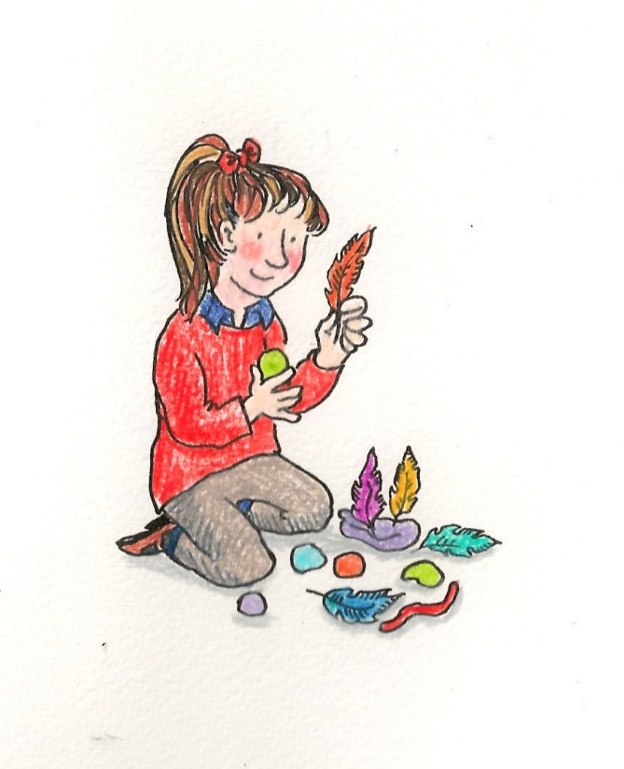
Ideas mapping activity

Explore these questions with your museum team...

- How SEND friendly is your museum currently? Work through this checklist with museum staff and honestly appraise your current facilities, exhibitions, resources and learning offer.

- Also think about staff skills in SEND knowledge, confidence in communication and providing an inclusive welcome.

- Include all staff in this appraisal who will come into contact with, plan for and develop an offer for SEND audiences.

- Remember non-school SEND audiences such as home school groups, families and social groups. How does their visit differ from schools and how does your museum interact with them?
Use the answers and the results from your ‘ideas mapping’ work to help shape a SWOT analysis of your museum and develop a plan for improving offer and facilities

SEND SWOT (assess your museum access!)

SWOT stands for – Strengths, Weaknesses, Opportunities and Threats and is a tried and tested method of reviewing and assessing almost anything! Divide a piece of paper into four quarters, one for each heading and brainstorm your way through the four sections. Be honest, clear and concise. Seeing the notes together will show overlaps and allow ideas to stand out. Often seeing threats written next to opportunities can shed light on how to manage or overcome them (sounds too simple? Try it and see!) Remember to include everyone in this exercise, every member of staff should be invested and ‘signed up’ to making your museum SEND friendly, not just the learning team!

Strengths | [Grab your reader’s attention with a great quote from the document or use this space to emphasize a key point. To place this text box anywhere on the page, just drag it.]  Weaknesses
[Grab your reader’s attention with a great quote from the document or use this space to emphasize a key point. To place this text box anywhere on the page, just drag it.]  Opportunities | Threats
Action Planning

From your SWOT analysis and ideas mapping, you should now have a clearer picture of areas where your museum can improve on SEND inclusivity. Use these to form a simple improvement plan . Identify who will action each element of the plan, what resources or research you need, and commit to a realistic timeframe in which they will be achieved. Remember it’s much easier and more rewarding to complete a simple job well, than to try to do too much and not deliver.
Here are some possible examples:
Need: Create an access page and access statement on the museum website
Action: Look at good examples of museum access pages elsewhere, then create your own, working in partnership with local SEND audiences and the museum web team. Publicise this to local special schools and disability groups.
Who by: Member of staff responsible for learning and access, working in partnership with local special schools and disability groups.
By when? Suggest 3-6 month timeframe from inception to completion

Need: Quiet space needed for calm time and feeding/medicine delivery.
Action: Identify room and clear space
Who by: Duty officer
By when: Start of term 2
Resources needed: Storage boxes, 5 x bean bags, 2 x folding tables and 10 x chairs

Need: Changing Places toilet
Action: Research the location of the nearest Changing Places Toilet.
Who By: Museum operations manager
By When: Easter break
Resources needed: Research the location of the nearest Changing Places toilet by visiting the Changing Places website, then add a link to it from the museum website, with information about how SEND visitors can find and access it.

Need: Inclusive museum learning workshop
Action: Work in partnership with SEND teacher to create workshop
Who By: Museum learning manager/team
By When: Three months from inception to completion
Resources needed: Time to develop a new workshop with a local special needs teacher. Time to trial the workshop.. Costs of materialshat the museum is not able to fulfil a SEND need completely itself (such as installing a Changing Places toilet) in which case clear signposting to the nearest facility Is the next best thing.
How to approach SEND schools and develop partnerships
High quality museum visits for SEND children come from developing them in partnership with special schools.
It can be daunting contacting schools, difficult to know who to speak to, and how to promote the value of a museum visit to busy teachers. So here’s some simple, tried and tested advice to help you get started…
First find a partner school contact your Local Authority for a list. Kent County Council have an excellent website that lists all the special schools in the county, plus mainstream schools with specialist units for SEND children.
https://www.kent.gov.uk/education-and-children/special-educational-needs/school-information-for-special-educational-needs-sen/Find-special-schools-and-schools-with-special-units#tab-1
Start here to identify schools you might like to work with. From a practical point of view it is good to start with a local school, ideally in the same town or within easy driving distance.
Send your target school(s) a friendly email outlining who you are and what you are looking to develop. Ask them if they’d like to be involved in creating an exciting new visit or resource, tailored to their requirements and linking to the national curriculum and topics already covered in school.
Invite at least two teachers from each school to a short initial meeting at the museum to introduce the project, and to see if they are willing to help. A twilight after-school session works well, about 4.30 to 6pm. Include a tour, a chance to investigate a few special artefacts, and refreshments and cake!
Address the invite to the head teacher by name (you can get details from the school website). Then follow up the email with a friendly telephone call to the school office to check they have received it and to ask if it can be passed on to the head or most appropriate teacher.
Offer an incentive to the school for helping. A free trial visit to test the new workshop works well. Or if the project is externally funded you can build in budget to back fill teacher time spent working on the project. If you haven’t got one already, think about creating a Teachers Panel at your museum… and make sure that special schools are represented on it!
Top Tips for creating a successful Special Needs school visit
Here are some Top Tips for creating a successful SEND visit. We’ve broken them down into things you need to plan in advance, have in place on the day of the visit and complete afterwards.
In Advance
- Get to know and learn from each other! Invite teachers to the museum. Show them round the galleries, make them aware of the existing schools offer, and commitment to work in partnership to develop new visits, tailored to students’ needs.

- Visit your partner school to meet the teachers and students who are coming on the trip. Discover what kind of learning/activities work best. Get to know each other. Brief the students on what to expect when they visit.

- Emphasise the ‘wow factor’ of museums - historic buildings full of incredible artefacts and stories to stimulate learning, curiosity and the imagination. Hands-on, multi-sensory and fun! Make sure your visit has the ‘wow factor’.

- Arrange a walkthrough of the museum with your partner teacher to discuss one or more key stories and objects it might be good to highlight as part of a visit. Think about how these can be brought to life in an exciting and multi-sensory way, and act as a starting point for creativity.

- As part of the walk through, consider how to make the visit as accessible as possible. Think about pre-visit info, what needs to go on the museum website, drop off/parking, access for children with a range of disabilities, toilets, lunchroom, the level and type of interpretation required, sounds and smells that may be encountered during a visit, and the type and best location for activities.

- Include the learning from this in your school visits info for special schools and on the access page of the museum website. See The Eureka Story – a practical toolkit for parents, teachers and children.www.eureka.org.uk/plan-your-visit/access-information/

- Make it easy! In developing a new resource, focus on a simple activity and do it well. Or adapt one that already works well in your venue or elsewhere. Look at case studies and best practice elsewhere. Don’t reinvent the wheel!

- You can develop a facilitated visit led by a museum educator, artist or trained volunteer.

- Alternatively, you can create resources for a teacher-led visit such as a museum trail, multi-sensory handling box or story sack to be collected at the front desk and give added value to a museum visit.

- Keep activities short and flexible and have an alternative just in case.

- Include multi-sensory elements. Things to touch, including touch tours, to try on, see in close-up detail, smell and hear.

- Art, craft and other making activities are great for this audience, as are interactive stories, including objects to handle, music, singing and action rhymes.
- Plan the visit on a quiet day with no other large groups.

- Book the lunchroom for the duration of the visit, just in case it’s needed as a chill out/quiet space, as well as for lunch.

- Think about how special school visits can be sustainable. Is there a model that covers the costs of museum staffing and resources, and is affordable for schools? Discuss the different options – facilitated visits, teacher-led visits and outreach. Develop your visit with this in mind.

- If possible, provide training for museum staff and volunteers on how to engage with SEND audiences. Find out if you already have staff or volunteers who are familiar with working with this audience.

- Let the school know you’d like to take some photos/film of the visit for reporting and publicity use. Ask if this is possible, and if so, make sure permission forms are signed off by the school in advance, and that you are aware of any students who can’t be included.

On the day
- Have plenty of museum staff and volunteers available to facilitate the visit. Make sure they’ve been well briefed as to what to do, are on hand to welcome the group, and support activities.

- Provide a room for the group’s exclusive use, ideally with accessible toilets nearby. This can be used for coat and bag storage, as a lunchroom, for creative activities and as a quiet room/chill out space if required.

- Offer refreshments or a space for schools to eat their own lunch.

- Make the visit special! Go behind the scenes, see an object not usually on display, meet a curator, artist or conservator. Use high quality art/craft materials. Make something special to take away.

- Create a visit of a few simple but fun elements. You don’t need to do the whole museum! Focus on one gallery or a few key objects on a popular theme, such as animals, toys, dinosaurs, museum treasures, a touch tour or sensory trail.

- Document the visit. Take lots of photos and film and encourage teachers and students to do likewise. Observe what works well and what can be improved. Write down teacher and student comments. You can brief a volunteer to do this.

Afterwards

- Develop creative follow up activities to be completed back at school.

- Celebrate the visit and student achievement. Provide an opportunity for students to celebrate their learning/display outputs. This could include a small art display at the museum, a social media blog about the visit or a short visit report by a student on the museum website.

- Write up the visit, including photos and comments from students and teachers to use in promote to other schools!

- Evaluate the visit. Meet up with your partner teacher and students, the museum team and volunteers to discuss what went well, and how similar visits can be improved in the future. Write this up in a short evaluation report.
- Using findings from your evaluation, adapt the visit outline ready for official launch to other schools and as a case study in a project toolkit.

Dos and Don’ts!!t would SEND n museums best practice/resources look like?

Do…
- Use props/handling collection
- Use short stories to hook an audience and break story down into bite size pieces
- Train staff and volunteers about appropriate language and non-verbal behaviour (body language)
- Train staff on how to use simple Makaton signs eg. “Hello how are you?”, “Wait”, “Stop!” “Yes/No”, “Good”, “Goodbye”
- Offer safe experiences that challenge boundaries
- Help children to experience something new and different
- Recognise all museum visit experience is valid and valuable. Keep activities loose and open ended, not target or end result driven.
- Prepare school staff and children with what to expect. If a member of museum staff/volunteer will be dressed in costume or acting in character, let the school know.
- Consider when appropriate, telling other museum visitors on the day about the SEND school visit planned. Allow/enable the school to have the visit they want without confrontation of other visitors (or staff!)
- Involve the children

Don’t…
- For children who have Autism, DON’T talk too much!
- Ignore individual personal space needs and conversely do be aware of some children’s need to touch and know how to act appropriately (if in doubt ask the teacher/assistant)
- Be inflexible to changing the route of your tour, what you are exploring or even what activity you had planned. Do be guided by the school staff.
- Be scared! SEND children are often very rewarding and fun to work with, do enjoy the experience and see it as a learning one for you too!

, DON’T talk too much!
SEND Families
Another important group of SEND visitors are families. Here’s a few ways their needs might differ to organised school groups:

- You probably won’t know when they are going to arrive!
- Families may not be fully aware of your SEND offer, resources or accessible facilities until they arrive, making their initial five minutes of orientation especially important.
- They may arrive with a multitude of different types of need, either because they have non SEND siblings and friends in their group or because they are visiting with other families with different needs (it’s not unusual for SEND families to visit together, strength in numbers and all that!)
- Although some may bring carers with them, the adult to child ratio is likely to be much less than with school visits.
- Lack of sleep, a stressful journey, even getting out of the car and visiting a new and therefore ‘strange’ place comes as part of the territory for SEND families. Patience, understanding and empathy go a long way to making them feel welcome and supported when they arrive. Their day has usually started a lot earlier than yours!
- Whereas formal learning groups will have a structure to their visit, either in timings and or activities, family visits are much more fluid. SEND families may need flexibility on accessing activities and leaving half way through if needed.
- Self-led activities, trails etc are useful to all families but especially SEND families as these support their visit. Encouragement to use handling collections, touch exhibits where allowed and explore with all senses helps families to create their own experiences and memories beyond their visit.
- Art and craft activities should be open ended, allowing for any level of participation. Remember the ‘end result’ rule that taking part in the activity is the important part, NOT what the end result looks like. For example instead of saying “we are making clay animals we saw in the painting” suggest “we are playing with clay, and you can make something you saw today if you like”. This removes ‘judgement’ and ‘failure’ from the equation at the start.
- As with SEND schools, contact with front of house staff is an essential part of the visit. Use clear language, explain who you are if asked and keep details simple. Friendly, helpful and confident staff, make a SEND family’s day and they are more likely to visit you again!
- Consider running a museum take over day or develop a regular SEND group such as The Mighty Mega Saturday Club at the Discover Children’s Story Centre in Stratford, London. This is a club for SEND children, their families and carers. Sessions provide a creative and open atmosphere for exploration, fun and interactivity, where children can take part in storytelling, music, dance, arts, crafts and immersive multi-sensory experiences.

We asked some SEND Families what they want from a museum visit …

“For me it’s thinking about others. How would you feel if you were excluded. If a little effort has been made to include everyone, that’s all we ask.”

“Things at the right height for a buggy which can be lower than a wheelchair.”

“A changing place toilet would be amazing. Exhibits that can be touched or interacted with. Verbal as well as written explanations of exhibits. Wide doorways and corridors. Space to negotiate around safely. Lifts to upper floors. Free carers admission.”

“In particular a changing place makes a world of difference for those who need it. For many families, it makes the difference between going somewhere and not going. We go to Tate Modern a lot because the access is so good (parking, changing place, lots of space, access events with BSL tours). We haven't been to any of the South Kensington museums (science, natural history, V&A) in many years, partly because there's no changing place anywhere within reach. I managed for years, and still can, just, on a good day, but my daughter is now an adult and it's more and more difficult.”

“Quiet times. Earlier entry for special needs families. Exhibits that are sensory based (good for all children). Free carers. Quiet room if possible. Blue badge parking. Changing Places toilet. Things visible from low height. Good access.”

“Please touch and don’t touch symbols would be great! Rather than my child getting cross at me for constantly being told no, a visual reminder that this is not personal would be great and where things can be touched that this is highlighted.

“As well as all the physical access points above, my daughter loves it when there's a BSL tour we can go on, or a video explanation in BSL; or at least subtitles on the videos. She hates it when interesting things are in showcases above her eye level.”

“Opportunities and space to pause with seats would be useful. I think this is a simple thing, but so useful to us when we go somewhere, just to pause and remind us of what’s happening now and going to be happening next.”

“Different drawers of interactive things for kids. Accessibility a must, changing space would be fab. Accessible viewing considerations. Opportunities and space to pause with seats would be useful. What about having little bookable activity workshops to launch the different exhibitions. What about having Makaton signs dotted about.”
Case Studies
Dover Museum, the Kent Mining Museum and the Royal Engineers Museum took part in the project and between September 2017 and March 2018.created and trialled exciting new visits and resources with local special schools.
The case studies summarise what each museum did and how. They include project aims, details of school visits and resources created, information on what worked well and what didn’t, top tips, the impact of the project and plans for the future.
As Dover Museum trialled two visits there are two case studies for this venue.

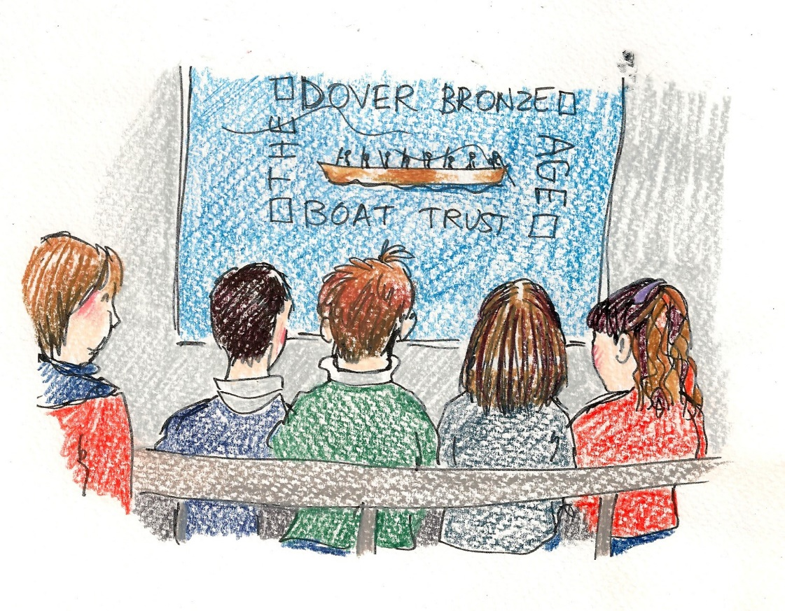

Case Study 1
Teacher-led visits at Dover Museum
Project aims
To create accessible teacher-led visits and pick up resources. A key aim was this should involve no additional staffing or resource costs, allowing it to be offered free to special schools as part of a teacher-led visit.
The museum worked with Simon Gulliford, history specialist at St Nicholas School, Canterbury to identify how the museum could support special school visits; to review access arrangements; and identify activities to develop.
Resources created
Easy to use resources to be picked up from the front desk, for independent use by teachers and pupils around the museum. Three different activities were created.
Reconstruct the Bronze Age boat
Children explore the Dover Bronze Age Boat Gallery and investigate the boat. They discuss why one end of the boat is missing and what it might have looked like, before reconstructing what they think the missing end of the boat looked like using modelling clay.
Find the Mystery Object Challenge
Students are given close up photos of 6 mystery objects to find in the Dover History Gallery together with A6 size viewing frames. They then discuss the objects.
Feely Bags and Sound Clips
For use in the Bronze Age Boat Gallery, including replica Bronze Age artefacts to handle such as a bronze axe head; soft toy farm animals; and the smell of beeswax (used for waterproofing the boat). The children guess what’s in the bag and describe it to others before the items and their Bronze Age associations are revealed. Sounds of the Bronze Age are also provided via Talking Tins. Children guess the sounds and match them to the objects, such as the sound of wood being chopped with an axe.

Impact
Museum staff and volunteers learnt about the access and learning needs of this audience and how to support a visit. This included a greater understanding of the needs of special schools at the museum, and the types of hands-on and multi-sensory activities that work best. A walk through of the museum to assess access needs, and opportunities for engagement was incredibly valuable. Children from St Nicholas School really enjoyed visiting, and gallery activities gave focus and structure to their visit. The children enjoyed hunting for the mystery objects using the laminated pictures and viewing frames. The simple nature of these activities means they can be used independently by special schools and SEND families with minimum of input from the museum team.
What worked well and what didn’t?
The children really enjoyed the activities which were pitched at an appropriate level. They encouraged children to explore existing displays and provided focus for the visit.
Top tips
Walk round with a teacher to do a simple access audit. As well as identifying things to improve, the notes you make can be simplified into an Access Page for your museum website.
Walk round with teachers and learning staff to identify ideas for activities and resources across the curriculum. Start with just one or two simple activities first to build confidence.
Ask teachers how to adapt the visit for children with different learning needs. Remember, older children need age-appropriate activities, but simplified.
Don’t overcomplicate! Simple activities work well.
Identify opportunities already present in the museum, for example things children can touch, and existing hands-on interactives.
Plans for the future
The access page of the Dover Museum website will be updated so that special school teachers and families of children with disabilities, are aware of access arrangements for special schools at the museum and new visits and resources for this audience.
Teachers commented it would be great to offer visiting special school groups the possibility of a creative session at the museum. This is being offered at a cost of just £70 to cover the cost of an artist to deliver the workshop.
Studies

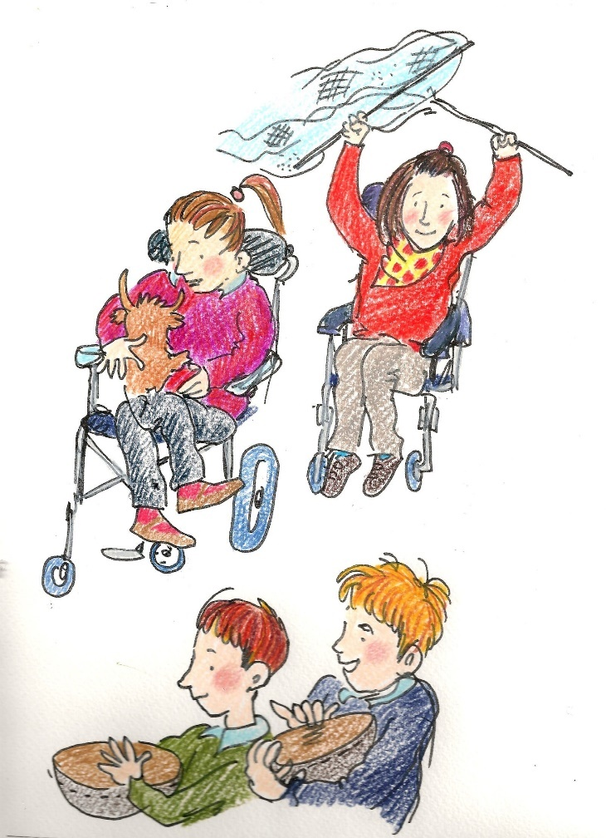
Case Study 2
Bronze Age Boat Sensory Story at Dover Museum
Project aims
To create a sensory story for special school children, including those with profound and multiple learning disabilities (PMLD).
Resources created
A sensory story introducing children to the Bronze Age Boat Gallery through a family and their farm animals was created in partnership with Simon Gulliford and Rosalie Maltby from St Nicholas School, Canterbury. The loosely scripted story (adaptable for different audiences) engages the children through rhythm, rhyme, repetition and gesture, and includes the building of the boat and a dramatic voyage out to sea! The kit which cost under £300 includes a story rug, tactile and sensory fabrics, soft toy animals, musical instruments, Talking Tins with press and play Bronze Age sounds, smells and replica artefacts to handle and investigate.
Impact
Museum staff and volunteers learnt about the different access and learning needs of this audience and how to support a visit. This included a greater understanding of the needs of special schools at the museum, and the types of hands-on and multi-sensory activities that work best. Sensory storytelling training for children with special needs, which formed part of the 2017 SEND Network Conference in London, was the catalyst in the development of this resource.
Children with PMLD from St Nicholas School enjoyed visiting the Museum. The sensory story made the visit a much more engaging and multi-sensory experience. Feedback from the school was it had been a really enjoyable and worthwhile visit. By promoting these new visits/resources to special schools, and to families of children with disabilities the museum will be able to build an important new audience.

What worked well and what didn’t
Teachers commented that the story was pitched at the right level, easy to follow, and age-appropriate, and that the children enjoyed the handling objects and animal sounds. Rosalie commented it would be good to use some simple Makaton signs, which have been included in the final activity outline.
Top tips
Sensory storytelling training with a professional storyteller experienced in working with special schools and children with PMLD is highly recommended if you are thinking of including storytelling in your museum offer. This is useful for the person creating the story, the storyteller who will be running the activity, and the head of your learning team.
Choose an atmospheric and quiet part of the museum for the storytelling activity. Have appropriate seating, story mat and space for wheelchairs.
Think about taking the children on a trail through the museum to get to the storytelling space and to discover some interesting objects and stories on the way. Make sure the story is pitched at the right level, easy to follow, and age-appropriate. Check in advance with teachers about this!
Involve children in the story all the time, through repetition rhyme, singing, actions animal noises and role play.
Include touch, smell, sound and colour. Feely bags and object handling work well. Include music and some fun musical instruments
Make sure you have enough objects for everyone to get involved, including multiples of the same thing.
Record push and play sound clips.
Include simple Makaton signs as part of delivery.
Plans for the future
Dover Museum staff and volunteers are receiving training on how to engage with this audience, including sensory storytelling training from a professional storyteller.

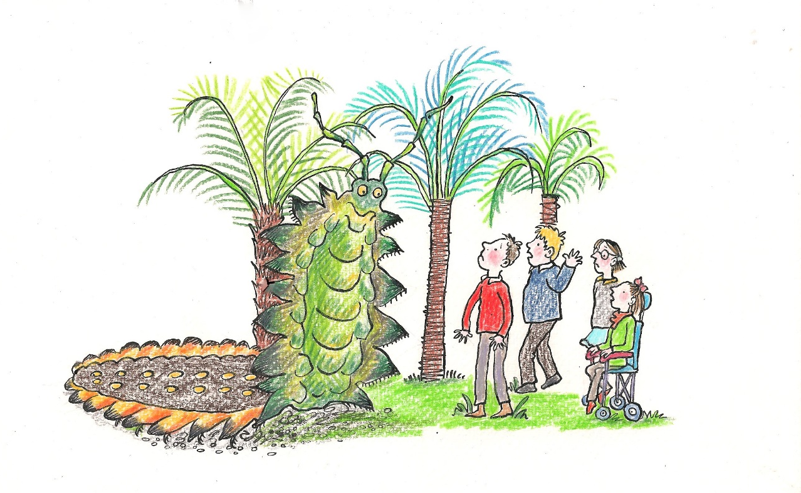
Case Study 3
Splendiferous Carboniferous sensory story
at the Kent Mining Museum
Project aims
To work in partnership with Elms School, Dover to create visits and resources inspired by the Kent Mining Museum collections and the Betteshanger Sustainable Parks site.
Resources created
A sensory story which introduces children to the plants and giant minibeasts of the Carboniferous, over 300 million years ago. This uses rhythm, rhyme, repetition and gesture. The storytelling kit includes props to recreate the Carboniferous forests, soft toy animals, and Kent coal fossils for children to handle and investigate. The highlight is when children meet Arthur (arthropleura), a six foot long prehistoric millipede. The sensory story kit is portable for use at the museum, or in school and community venues. Ideas for creative activities inspired by the story are included for follow up work in the classroom.
Two of these creative activities were trialled. The first was a group activity to assemble a 1m long cardboard model of arthropleura from 9 separate pieces. The model was then left with the class to complete and paint.
The second was a simple fossil moulding activity using self-hardening clay. Children chose a fossil cast and pressed a ball of clay into it to create a 3 dimensional copy of the original fossil. They were also given the opportunity to Ask the expert questions about rocks, minerals and fossils.
Impact
The outreach visit to Elms School was a great success and the museum and school are committed to developing and trialling new resources together. The school are a member of the museum’s recently established Learning and Engagement Advisory Panel. Museum staff will learn about the different access and learning needs of this audience and how to support a visit.

What worked well and what didn’t?
The children really engaged with the sensory story joining in the rhymes, repetition and gestures with great enthusiasm. They enjoyed problem-solving, working well as a team to build arthropleura and asked lots of questions about it and what it ate. They liked finding out about Betteshanger Sustainable Parks (many had already visited to use the cycle track and play park, and shared their memories) and enjoyed finding out about the coal mine. The class teacher Nathan commented on how well the children engaged. One boy who is normally very quiet, contributed with great enthusiasm to share his impressive knowledge of this subject. A second boy who is normally disruptive with new people also engaged very well.
Top tips
Think about whether your activity can be run as an outreach activity in school and community venues as well as at the museum. You’ll reach a larger audience. Remember, don’t make individual storage boxes too heavy and buy a trolley or sack barrow to wheel them around.
Liaise with the teacher in advance on car parking, room set up, the needs of the children in the class and which activities will suit them best. Don’t worry of the children are a little disruptive or need some time out. This is usual behaviour for some classes. Stay calm and let the teacher deal with it and then carry on.
Remember the wow factor. Some exciting fossils, especially when revealed from within a split nodule, or a giant centipede that crawls out of the undergrowth, really grab children’s attention and sparks their imagination and sense of wonder!
Think of some simple creative activities you can incorporate in your workshop, or follow up activities teachers can deliver in the classroom inspired by your visit. Include information and photos of these on the museum website.
Plans for the future
Kent Mining Museum staff and volunteers will be receiving training on how to engage with this audience. The museum are engaging with local special schools in the development and trialling of new school workshops and resources. The museum are developing other resources for this audience including the commissioning of a new multi-sensory story mat of the Kent coalfield. Elms School are a member of the museum’s new Learning and Engagement Advisory Panel (LEAP). The learning and access pages of the Betteshanger Sustainable Parks (Kent Mining Museum) website will include information for special school teachers, and families of children with disabilities, so they are aware of access arrangements and visits and resources for this audience.
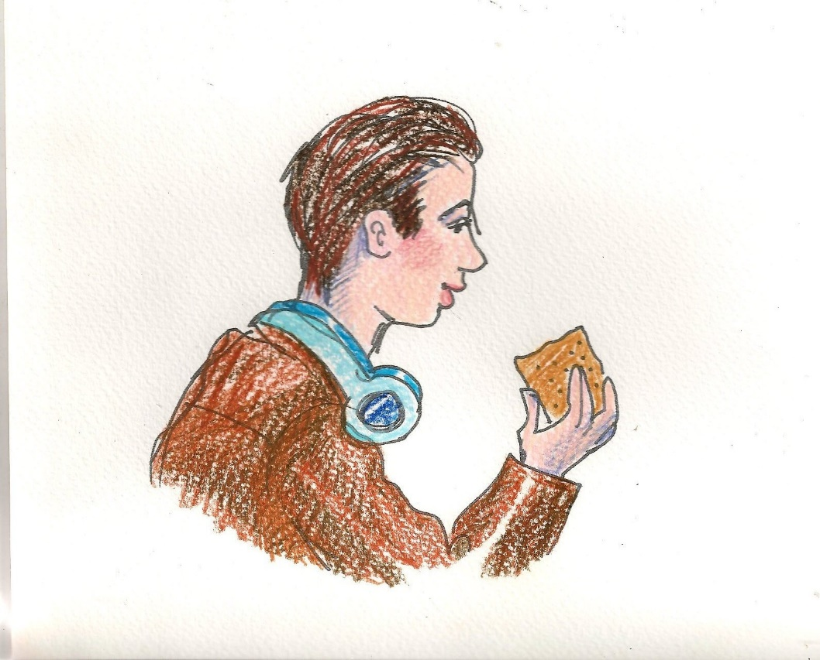

Case Study 4
Visual Gallery Guide and First World War loan box at the Royal Engineers Museum

Project aims
To create a Visual Gallery Guide and a First World War loans box for schools to use before they visit.
Resources created
The first resource is a Visual Gallery Guide. This is a flip book of images of key objects/exhibits in one of the museum galleries for schools to find during their visit. Each image has a small amount of text on the back so children know what it is.
The second resource is a First World War loan box for use by schools before they visit the museum. The box is themed around a 14 year old boy soldier whose diary is at the museum. It includes replicas of items soldiers would have had in the trenches, with ideas for activities inspired by them. For example a replica soldier’s tunic for children to try on, with scraps of the same rough woollen fabric the teacher can freeze to show the harsh conditions soldiers were living in.
Impact
Museum staff feel more confident in approaching schools to work with them to
develop ideas and resources. SEND schools will be able to use these resources to enhance their visit. Teachers will feel more confident in the gallery spaces.

What worked well and what didn’t?
The support we have been given throughout the project has been brilliant. There was always someone at the end of the phone and it was great to share ideas at meetings. I felt there was more emphasis on teacher time than museum staff time which in reality did not work as the museum staff did most of the work creating the resource.

Top tips
Don’t overcomplicate things. I’d planned the ‘Visual Gallery Guide’ to have a sentence rather than just the object name on the front, but it was suggested by Louisa, my partner teacher, that less is more.
Use an accessible font. Some fonts are easier to read than others.

Plans for the future
The Museum is hoping to make itself more SEND friendly by being able to offer the ‘Visual Gallery Guide’ to groups or families. Our long term aim is to become an Autism Friendly Museum.

Appendix 1 – Legal framework of Disability

The Equality Act 2010
Discrimination means treating you unfairly because of who you are. The Equality Act 2010 protects you from discrimination by:
- employers
- businesses and organisations which provide goods or services like banks, shops and utility companies (and museums – we added this one though!)
- health and care providers like hospitals and care homes
- someone you rent or buy a property from like housing associations and estate agents
- schools, colleges and other education providers
- transport services like buses, trains and taxis
- public bodies like government departments and local authorities.
There are nine protected characteristics in the Equality Act. Discrimination which happens because of one or more of these characteristics, is unlawful under the Act. We all have some of these characteristics - for example, sex or age - so the Act protects everyone from discrimination.
If you’re treated unfairly because someone thinks you belong to a group of people with protected characteristics, this is also unlawful discrimination.

What are the protected characteristics?
The characteristics that are protected by the Equality Act 2010 are:
- age
- disability
- gender reassignment
- marriage or civil partnership (in employment only)
- pregnancy and maternity
- race
- religion or belief
- sex
- sexual orientation

Discrimination by association
The Act also protects you if people in your life, like family members or friends, have a protected characteristic and you're treated unfairly because of that. This is called discrimination by association. For example, if you're discriminated against because your child is disabled.
The Children and Families Act 2014 has been described as the biggest reform to child welfare legislation in 30 years. Part 3 of the act specifically covers children and young people with Special Educational Needs and Disabilities (SEND from birth to 25 years). It outlines what Local authorities must do including involving families and children in discussions and decisions relating to their care and education; and provide impartial advice, support and mediation services.

Appendix 2 Useful links

DCN - Disability Co-operative Network for Museums
http://www.musedcn.org.uk/

Centre of Accessible Environments
CAE offers consultancy for access audits and accessible interpretation and guidelines particularly physical access as well as intellectual.
http://cae.org.uk

National Register of Access Consultants
The National Register of Access Consultants (NRAC) is an independent UK wide accreditation service for individuals who provide access consultancy and access auditor services.
http://www.nrac.org.uk/

Improving Access to Historic Buildings and Landscapes by Historic England
https://historicengland.org.uk/advice/technical-advice/easy-access-to-historic-buildings-and-landscapes/

Equalities Act 2010 guidance –
https://www.citizensadvice.org.uk/Documents/Advice%20booklets/equlity-act-2010-overview.pdf

The Children and Families Act 2014 Part 3: Children and young people with special educational needs and disabilities A briefing from the Council for Disabled Children
http://councilfordisabledchildren.org.uk/sites/default/files/field/attachemnt/ChildrenAndFamiliesActBrief.pdf
Government Green Paper “Support and Aspiration: A new approach to special educational needs and disability”
https://assets.publishing.service.gov.uk/government/uploads/system/uploads/attachment_data/file/198141/Support_and_Aspiration_Green-Paper-SEN.pdf
Special educational needs and disability code of practice: 0 to 25 years
https://assets.publishing.service.gov.uk/government/uploads/system/uploads/attachment_data/file/398815/SEND_Code_of_Practice_January_2015.pdf
Social Model of Disability
https://www.scope.org.uk/about-us/our-brand/social-model-of-disability

The UN Convention on the Rights of the Child
https://www.unicef.org.uk/what-we-do/un-convention-child-rights/
Changing Places
Best practice advice on creating fully accessible toilets
https://www.changing-places.org/
Collaborative Alliance of Special Schools (CLASS)county. http://www.classtsa.org.uk/
Euan’s Guide
Access reviews written by disabled people about a wide range of venues, including Top Tips for Museums and Galleries https://www.euansguide.com/news/top-tips-for-museums-and-galleries/

Appendix 3 – Disability awareness training

Training is vitally important for museum staff and volunteers, providing the skills and confidence to welcome and engage with SEND children and their families. It’s possible that you will be able to ask your SEND teacher partner to deliver some of this or work with a local special needs group.
Some disability charities such as the Kent Association for the Blind also run their own training courses and are a good contact for specific impairment needs.
There are also some great organisations who specialise in access awareness training for the cultural and heritage sector. In no particular order here are a few (SEMDP has used Visits Unlimited in the past to deliver its museum access training).

http://www.visitsunlimited.org.uk/
https://www.accessforalluk.com/
http://www.artbeyondsight.org
http://www.accessdesignsolutions.co.uk

staff and volunteers
Disability Awareness

CPD opportunities for teachers
It is important to make local teachers aware of the excellent offer you have developed with and for special schools, and of the many creative ways they can use your museum and collections across the curriculum. Why not work with your local special school network to host a special CPD day at your museum where teachers can come along and find out about your resources, how to work in partnership with you, and to gain skills and confidence in using the museum. This might include some object investigation training, as well as a creative skills workshop led by an artist or storyteller.

Appendix 4 Access and Resources Checklist

Access and Resources Checklist for SEND visits
Use this checklist when you go around your museum with a special school teacher to identify access arrangements and activities you already have in place for SEND audiences, and ones you might add in future. Then list these on the access and Special Schools pages of the museum website.
Item | Notes/action points
Contact details of named museum staff member(s) for organising special school and SEND family visits?
Is there an Access Page on the museum website? If not, create one.
Is there up to date information about the SEND formal and informal learning offer on the museum website for schools and families? And information on how to get to the venue? If not create/update this.
Is there minibus drop-off and parking on site? Make clear how schools can book this. Or list the nearest public car parks and costs?
Is there a visual guide to the museum on the website? If not consider creating one.
Is there wheelchair access to all galleries? If not, provide details, and alternative arrangements in place.
Give the location and type of accessible toilets, both on site or nearby.
Give the location and details of the nearest Changing Places toilet if within walking distance?
Are there wheelchair accessible lifts. List where they are.
Highlight fire evacuation procedures, including for wheelchair users. Are there any Evac Chairs?
Are there any sounds around the museum. List these on the website as they may be potentially distracting to some children.
What opportunities for drawing/other creative activities exist around the museum? Identify the best spaces and highlight these
Are there hands-on or interactive activities? If so highlight them.
Are there opportunities to touch tactile exhibits. Which objects would it be possible to touch? List them, and any special conditions.
Is there large print or audio description?
Do you employ audio describers or signers to facilitate visits? If so, provide details.
Highlight multi-sensory learning activities that could be created for SEND audiences inspired by the building and collections. Think about which you will develop first, starting with something simple and low cost.

Appendix 5 Good practice examples
Explore these links to resources and organisations we have found useful and inspirational in developing our SEND visits and activities.
Eureka
Visit https://www.eureka.org.uk to see how the National Children’s Museum meets the needs of a wide range of SEND audiences including the introductory film Access All Areas, The Eureka Story - a practical tool for visitors with autism and other sensory conditions, a good Accessibility Guide, adapted workshops, sensory stories, trained enablers and an Extra Pair of Hands - two hours free visit support for families with children with special educational needs.
Kids in Museums
Kids in Museums https://kidsinmuseums.org.uk encourages and promotes family-friendly provision in museums and galleries, including excellent advice on how museums can better welcome families with a wheelchair user https://kidsinmuseums.org.uk/resources/#wheelchair and families and young people with autism https://kidsinmuseums.org.uk/2016/04/04/welcoming-families-and-young-people-with-autism/
Lis’n Tell
Louise Coigley of Lis’n Tell offers Live Inclusive Storytelling training to museums and galleries, giving participants the confidence to enhance their storytelling skills through rhythm, role, rhyme, repetition and ritual to enable and include the spontaneous intentional participation of children with speech, language and communication needs. https://www.lisntell.co.uk/
Makaton
Makaton is a language programme using signs and symbols to help people to communicate. It is designed to support spoken language and the signs and symbols are used with speech, in spoken word order. It is used by many children and young people with Special Educational Needs and Disabilities. https://www.makaton.org/
Mind’s Eye
Anne Hornsby of Mind’s Eye provides training in audio description, descriptive tours touch tours and handling sessions for museums and galleries to enhance provision for blind and partially sighted visitors. http://www.mindseyedescription.co.uk/
Museum of London Early Years Toolkit
Packed full of exciting ideas and practical advice on improving museum visits for the under 5s The Museum of London Early Years Toolkit is also worth looking at in developing exciting and multi-sensory visits and activities for SEND audiences. https://www.museumoflondon.org.uk/earlyyearstoolkit
Pitt Rivers Museum
Case study of an inspirational Arts Award Explore project with Iffley Academy
http://pittrivers-education.blogspot.co.uk/2017/02/iffley-academy-students-complete-their.html
South East Museums
Advice and support for museums in Kent and the South East looking to develop visits and resources for SEND audiences.
http://southeastmuseums.org/
Special Educational Needs and Disabilities Network and Conference
A London-based network offering peer support and imaginative approaches to interpreting museums, galleries and heritage sites for visitors with special educational needs and disabilities. The network meet every quarter with a free annual conference including a keynote speaker and practical and interactive workshops.
Special Needs Advisory and Activities Project (SNAAP)
A Kent-based charity which aims to improve the quality of life of disabled children and young people, their carers and families by providing information, support, advice and leisure activities in a friendly, safe and non-judgemental environment. A great site to promote accessible visits and activities. http://www.snaap.org.uk/

Discover Children’s Story Centre access statement
http://www.discover.org.uk/access-statement/

RNIB - How to design and curate accessible exhibitions
https://www.rnib.org.uk/rnibconnect/how-to-accessible-exhibitions

AIM Association of Independent Museums - How to Market Accessibility
https://www.aim-museums.co.uk/how-to-market-accessibility/

The SENDCo says next week’s SEND visit will include 3 PMLD, two VI and 3 ADHD children

Perhaps we need to include a Glossary of Terms!

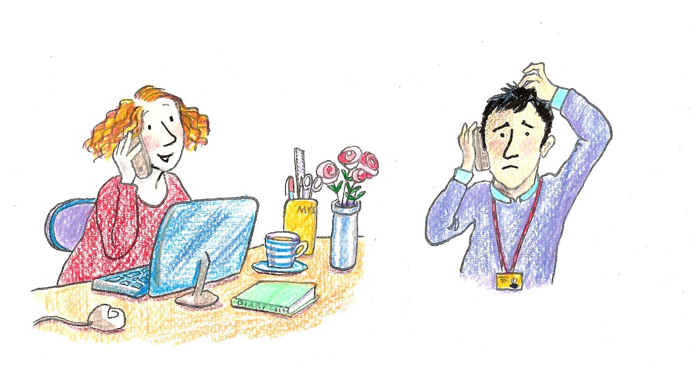

Appendix 6 Glossary of terms

Glossary of terms
Term | Acronym | Meaning
Access page | Not applicable | A really important page that should be just one click away from the home page of every museum website! It should include clear information for visitors with special educational needs and disabilities to plan their whole visit.
Access statement | Not applicable | Usually found on the access page this highlights in more detail what is available at the museum for different SEND audiences, often on a gallery by gallery basis.
Accessible text | Not applicable | All print whether on the website, in interpretation, exhibitions or leaflets needs to be accessible in a large clear font with high contrast. This makes reading it easier and more enjoyable for all but is particularly important for partially sighted people. See the RNIB website for details.
Accessible toilet | Not applicable | A wheelchair accessible toilet
Adapted workshops | Not applicable | There’s no need to re-invent the wheel. Many existing workshops and activities can be made inclusive or accessible to specific audiences with a little thought and planning.
Attention Deficit Disorder | ADD | Attention Deficit Disorder (ADD) is a term used for people who have excessive difficulties with concentration without the presence of other ADHD symptoms such as excessive impulsiveness or hyperactivity
Attention Deficit and Hyperactivity Disorder | ADHD | Attention Deficit Hyperactivity Disorder (ADHD) is a behavioural disorder that includes symptoms such as inattentiveness, hyperactivity and impulsiveness.
Audio description | AD | Describing a museum object painting or gallery in words for blind or partially sighted people
Autistic Spectrum Disorder | ASD | Autistic Spectrum Disorder (ASD) affects social interaction, communication, interests and behaviour. It includes a range of different conditions from High Functioning Autism to Asperger’s Syndrome
Changing Places toilet | Not applicable | A toilet designed to meet the needs of people with profound and multiple learning disabilities, as well as other physical disabilities. A Changing Places toilet is designed with the extra space and equipment for this important group of visitors to use it safely and comfortably. It should be the aim of all museums to get one! See changing-places.org
Hearing Impairment | HI | A partial or total inability to hear.
Inclusive storytelling | Not applicable | Stories that involve the audience actively participating in the story, using music, gesture, rhyme and repetition. The storyteller responds to the needs and suggestions of the audience to create a story rather than reading from a book.
Kent Association of Special Schools | KASS | A group of special schools across Kent who work together and deliver the same curriculum. A good network through which to publicise SEND visits and activities!
Language through Colour | Not applicable | A simple colour-coded resource to help children understand the meaning of words and develop their reading and writing. If you create resources in partnership with a special school they might help you design resources in this format so children can understand them better. Used by the Kent Association for Special Schools.
Makaton | Not applicable | A language programme using signs and symbols for children who can’t communicate effectively through speaking. If you develop resources in partnership with a special school they may suggest a few Makaton signs to help your engagement with this audience. Used by the Kent Association for Special Schools.
Moderate Learning Difficulty | MLD | People with a Moderate Learning Difficulty will often mix well with others and be able to cope with many everyday tasks. However, they may need support in other areas of their life.
Multi-sensory resources | Not applicable | Ones that encourage the user to explore through touch, smell, sound, sight and sometimes even taste.
Physical Disability | PD | The long-term loss or impairment resulting in a limitation of physical functioning, mobility, dexterity or stamina. Due to the functional loss the person will experience the inability to perform normal movements such as walking and mobility, sitting and standing, use of hands and arms, muscle control, etc.
Profound and Multiple Learning Difficulties | PMLD | Commonly associated with pronounced developmental delay, significant physical and sensory impairments and epilepsy. Most people with profound and multiple disabilities will have physical disabilities, be unable to walk and have to use a wheelchair. They may have hearing and sight problems. They will communicate non-verbally, that is, they will not speak or if they do, will use only a few words. Some may use signs and symbols or look and point to what they want.
Quiet Space | Not applicable | A quiet room where a child can have some time out during a museum visit.
SEN | Special Educational Needs | Special Educational Needs (SEN) is a legal term. It describes the needs of a child who has a difficulty or disability which makes learning harder for them than other children their age. About one in five children has SEN at some point.
SEND | Special Educational Needs and/or Disabilities | Widely used to describe children and young people with a broad range of needs that can affect their ability to learn including…  - behaviour or ability to socialise  - reading and writing  - ability to understand things  - concentration levels  - physical ability
SENDCo | Special Educational Needs and Disabilities  Coordinator | The SENCO is a qualified teacher whose role is to ensure that children with special educational needs and disabilities receive the support they need.
SEND Network | Not applicable | A network of museums and galleries in London and the SE who support and promote best practice in working with and developing resources for SEND audiences. They run some excellent training courses as well as the annual SEND Network Conference.
Sensory Story | Not applicable | Brings the story of an object or painting to life through the senses… The story might include items to touch, hear and smell, or include elements of music, dance or drama inspired by it.
Severe Learning Difficulty | SLD | Learners with Severe Learning Difficulties are likely to have extreme difficulty with reading and writing and may also require help with face-to-face communication.
Social Stories | Not applicable | Created for visitors on the autistic spectrum, these are short descriptions of a particular situation, event or activity (such as a visit to a museum) which include information about what to expect. They often include photographs or are in the form of a short film.
Specific Learning Difficulty | SpLD | Affect the way information is learned and processed including dyslexia, dyspraxia/DCD, dyscalculia, ADD, ADHD
Storymat | Not applicable | A colourful tactile fabric mat including different textures used for multi-sensory storytelling. Often in the form of a map, with pockets in which artefacts and multi-sensory objects are hidden, and with fabric story characters around whom stories are created.
Talking Tins | Not applicable | Low cost sound recording and play devices that work well in gallery settings for short descriptions or sounds (up to 40 seconds long).
Visual Impairment | VI | A degree of sight loss that may cause people difficulties with normal daily activities such as driving, reading, socializing, and walking.
Visual Gallery Guide | Not applicable | Large images of exhibits and objects in a museum gallery with minimal accompanying text

A very Big Thank You! to the following people who took part in this special project
Amber Cottee Royal Engineers Museum
Lynda Pearce Dover Museum
Darran Cowd Kent Mining Museum
Francesca Goodhart Kent Mining Museum
Mady Outen Kent Mining Museum
Simon Gulliford St Nicholas School
Rosalie Maltby St Nicholas School
Sean Mohan Elms School
Mandy McEnroe Elms School
Nathan Ingleston Elms School
Louisa Dawes Grange Park School
Charlotte Firmin Illustrator
Martin Crowther Heritage Learning Consultant
Sam Bowen Museum Development Officer (Kent and Medway)
Parents and carers of SEND children who provided advice and quotes on family visits
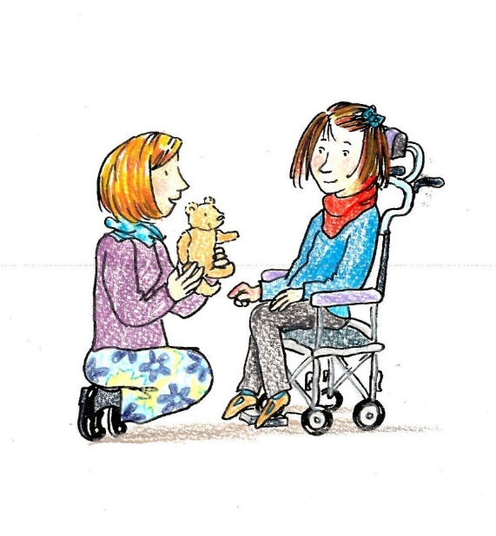
And last but not least all the inspirational children who brought this project to life.

